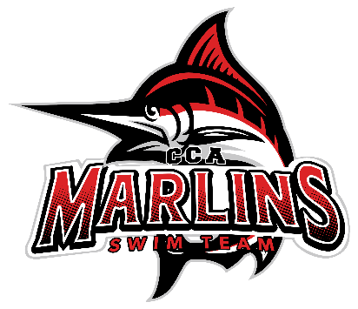

Marlins Board Meeting Minutes Recap (8/19/25)
Attendance: Brooke, Juliet, Kevin, Buffy, Steven, Julie, Susan, Amina, Whitney
1. Meet Schedule
- Brooke: Working on getting confirmation on NC meets; currently placing them as tentative on the schedule.
2. Open Houses Update
- Amina: The event went great! The Lancer Lot was very busy.
3. Amina’s New Role
- Amina: Has accepted the position of Executive Director of Marlins.
4. Organizational Chart
- Brooke: Presented the new organizational chart with Amina in her new role as Executive Director.
5. Coaching Rotations
- Amina: Discussed the strategy for coach rotation to help coaches get to know each swimmer and learn new drills and strategies.
6. Survey Results
- Brooke: The two main comments from the survey focused on Coaching and Communications.
- Out of 131 emails sent, 48 surveys were returned.
- Feedback varied from requests for additional lane availability to suggestions for better communication.
- Noted that N2X is enjoyable and Buffy is highly regarded.
- The board is discussing ways to incorporate survey suggestions into practice.
7. Texting App and Parental Involvement
- The board met with Amanda Foutz earlier in August; she is interested in implementing a texting app and enhancing parental involvement.
- Susan suggested the Band app, with Julie and Buffy supporting this suggestion.
- Kevin and Brooke noted their experience with the "Group Me" app.
8. Swim Lesson Update
- Susan: Swim lessons will be held Tuesday and Wednesday at 3 PM at CAC.
- No lessons will occur at the Lancer Lot; those participants will be referred to Mary Hamilton.
- CAC sessions will run for 7 weeks, with a large break during the high school swim season. Lessons will resume post-season.
- Morgan S. will be assisting Susan and Kevin in starting the new 3rd swim group at Lancer Lot.
9. Masters Coach
- The team is currently looking for a Masters coach.
Next Meeting: Scheduled for September 23, 2025, at 8:30 PM (virtual).

